Volatility correlation: GBPUSD and EURGBP
Method 25 / daily |log returns| / rho_vol / Alpari D1 full available history (realized deferred)

Study setup
Logical pair: GBPUSD , EURGBP
Broker symbols: GBPUSD_i , EURGBP_i
Snapshot: 2026-11-03_majors_alpari_D1
Timeframe: D1
Matched return window: 1999-01-06 to 2026-11-02 (UTC bar dates)
Matched return count n: 7199
Dropped unfinished last bar dated 2026-11-03 UTC after a tick-volume check against the prior complete day.
Statistic: rho_vol = Corr(|log return_L|, |log return_R|)
rho_realized: not computed (no intraday buckets in this snapshot)
Complete matched rows (Excel): GBPUSD-EURGBP_Vol_D1.xlsx
Complete matched rows (HTML table): GBPUSD-EURGBP_Vol_D1_data.html

Method carried forward
Volatility correlation rho_vol = Corr(|x_t|, |y_t|) measures whether absolute daily log returns of close move together in size, regardless of sign. Quotes are not inverted. Same-sample signed Pearson r is a side check. The formula sheet also defines within-day realized correlation rho_realized,d from intraday buckets; this v001 uses the Alpari D1 snapshot only, so rho_realized is not computed (no intraday buckets). This is not causation and not a trading signal.

Results (headline)
rho_vol: 0.399715
Pearson r (signed): -0.397845
mean |GBPUSD|: 0.00412384
mean |EURGBP|: 0.00354014
rho_realized: n/a (D1-only snapshot)

Conclusion
Headline rho_vol for GBPUSD and EURGBP: 0.3997. Signed Pearson r = -0.3978. Mean |return|: 0.004124 (GBPUSD), 0.003540 (EURGBP). rho_realized not computed (D1 snapshot has no intraday buckets). This is absolute-move co-movement, not a trading signal.

Charts
Daily closes

Daily log returns

Absolute returns scatter
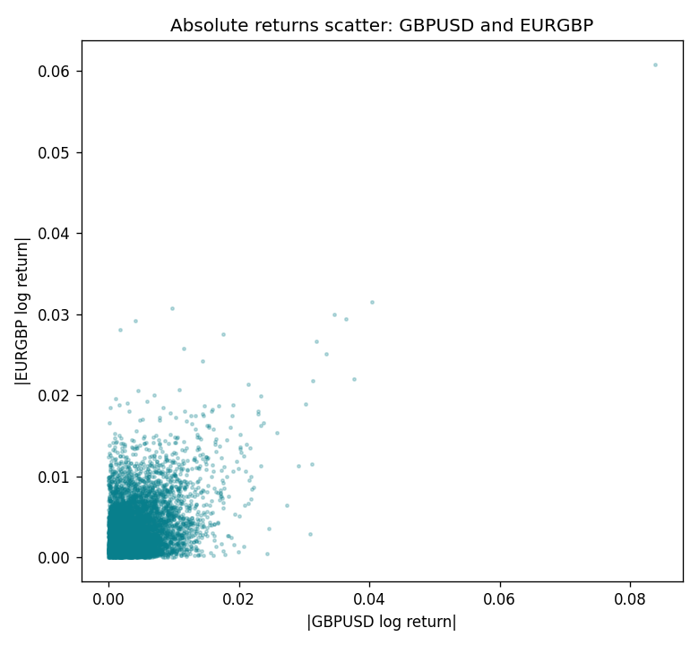

Data report
Matched rows are in the sibling Excel workbook named GBPUSD-EURGBP_Vol_D1.xlsx. Embedding all rows as a Word table is impractical; this file holds column summaries and the first and last 15 matched rows.
Columns: time, GBPUSD_open, EURGBP_open, GBPUSD_high, EURGBP_high, GBPUSD_low, EURGBP_low, GBPUSD_close, EURGBP_close, GBPUSD_tick_volume, EURGBP_tick_volume, GBPUSD_spread, EURGBP_spread, GBPUSD_real_volume, EURGBP_real_volume, GBPUSD_log_return, EURGBP_log_return, GBPUSD_abs_return, EURGBP_abs_return
Column summaries (matched calculation rows)
column | count | mean | std | min | 25% | 50% | 75% | max
GBPUSD_open | 7199 | 1.5160931 | 0.21831499 | 1.06854 | 1.324955 | 1.5114 | 1.63186 | 2.1066
EURGBP_open | 7199 | 0.78665041 | 0.09676322 | 0.5734 | 0.6873 | 0.83367 | 0.865175 | 0.9769
GBPUSD_high | 7199 | 1.5223838 | 0.21887686 | 1.08366 | 1.32978 | 1.5181 | 1.6384 | 2.1161
EURGBP_high | 7199 | 0.78972718 | 0.09713886 | 0.5789 | 0.68935 | 0.83657 | 0.86804 | 0.9799
GBPUSD_low | 7199 | 1.5097628 | 0.21753729 | 1.03518 | 1.3194 | 1.50323 | 1.62442 | 2.0983
EURGBP_low | 7199 | 0.78395066 | 0.09658082 | 0.5682 | 0.6853 | 0.83147 | 0.862765 | 0.9661
GBPUSD_close | 7199 | 1.5161471 | 0.21826306 | 1.06879 | 1.325055 | 1.51122 | 1.63216 | 2.1065
EURGBP_close | 7199 | 0.78669405 | 0.09676312 | 0.5735 | 0.6875 | 0.8337 | 0.86528 | 0.977
GBPUSD_tick_volume | 7199 | 94850.986 | 153561.38 | 62 | 9998.5 | 52911 | 91818.5 | 1273370
EURGBP_tick_volume | 7199 | 86949.029 | 145390.09 | 154 | 6517.5 | 44265 | 81326 | 1424684
GBPUSD_spread | 7199 | 26.96055 | 19.19062 | 0 | 11 | 20 | 50 | 50
EURGBP_spread | 7199 | 21.393666 | 19.14328 | 0 | 4 | 13 | 50 | 50
GBPUSD_real_volume | 7199 | 3.5570778e+09 | 8.4449923e+10 | 0 | 0 | 0 | 0 | 2.4038164e+12
EURGBP_real_volume | 7199 | 2.7805214e+10 | 1.3507095e+11 | 0 | 0 | 0 | 0 | 3.5726265e+12
GBPUSD_log_return | 7199 | -3.133e-05 | 0.00564236 | -0.08388241 | -0.00313644 | 2.978e-05 | 0.00317207 | 0.03112653
EURGBP_log_return | 7199 | 2.179e-05 | 0.00487166 | -0.03067367 | -0.0026225 | -0.00010035 | 0.00256076 | 0.06075387
GBPUSD_abs_return | 7199 | 0.00412384 | 0.00385081 | 0 | 0.0014515 | 0.00315302 | 0.00568515 | 0.08388241
EURGBP_abs_return | 7199 | 0.00354014 | 0.00334652 | 0 | 0.00119473 | 0.00260268 | 0.00485948 | 0.06075387
First 15 matched rows (selected columns)
time | GBPUSD_log_return | EURGBP_log_return | GBPUSD_abs_return | EURGBP_abs_return
1999-01-06 | -0.00060452184 | -0.013303338 | 0.00060452184 | 0.013303338
1999-01-07 | -0.002118709 | 0.011051402 | 0.002118709 | 0.011051402
1999-01-08 | -0.0058954193 | -0.004943862 | 0.0058954193 | 0.004943862
1999-01-11 | -0.0056851331 | -0.0012752393 | 0.0056851331 | 0.0012752393
1999-01-12 | 0.0022657001 | 0.0033970309 | 0.0022657001 | 0.0033970309
1999-01-13 | 0.0091330396 | 0.00042381861 | 0.0091330396 | 0.00042381861
1999-01-14 | 0.0019376331 | -0.0019793588 | 0.0019376331 | 0.0019793588
1999-01-15 | -0.0017558204 | -0.0076715819 | 0.0017558204 | 0.0076715819
1999-01-18 | 0.0012112405 | 0.00071280921 | 0.0012112405 | 0.00071280921
1999-01-19 | 0.0018745281 | -0.0014261269 | 0.0018745281 | 0.0014261269
1999-01-20 | -0.0049053846 | 0.0019960086 | 0.0049053846 | 0.0019960086
1999-01-21 | 0.0031518998 | -0.00071240297 | 0.0031518998 | 0.00071240297
1999-01-22 | 0.0024781662 | -0.0017118406 | 0.0024781662 | 0.0017118406
1999-01-25 | 0.0012066366 | -0.0054402425 | 0.0012066366 | 0.0054402425
1999-01-26 | 0.00072328374 | -0.00057438255 | 0.00072328374 | 0.00057438255
Last 15 matched rows (selected columns)
time | GBPUSD_log_return | EURGBP_log_return | GBPUSD_abs_return | EURGBP_abs_return
2026-10-13 | 0.0036434319 | 0.00020130374 | 0.0036434319 | 0.00020130374
2026-10-14 | -0.0049164679 | 0.0011241873 | 0.0049164679 | 0.0011241873
2026-10-15 | 0.0065976411 | -0.00087557391 | 0.0065976411 | 0.00087557391
2026-10-16 | 0.0037592051 | -0.0020380844 | 0.0037592051 | 0.0020380844
2026-10-19 | -0.0017500314 | -0.00056950988 | 0.0017500314 | 0.00056950988
2026-10-20 | 0.0055923442 | -0.0035906254 | 0.0055923442 | 0.0035906254
2026-10-21 | 0.0012476328 | -0.00140647 | 0.0012476328 | 0.00140647
2026-10-22 | 0.00022396082 | -0.0018743924 | 0.00022396082 | 0.0018743924
2026-10-23 | -0.0021146949 | 0.00082421033 | 0.0021146949 | 0.00082421033
2026-10-26 | -0.0024340661 | 0.00013133309 | 0.0024340661 | 0.00013133309
2026-10-27 | -0.0023648393 | -0.0019957343 | 0.0023648393 | 0.0019957343
2026-10-28 | 0.0015771808 | 0.00066967224 | 0.0015771808 | 0.00066967224
2026-10-29 | 0.0035881935 | -0.0011722209 | 0.0035881935 | 0.0011722209
2026-10-30 | 0.0013450605 | -0.0024205543 | 0.0013450605 | 0.0024205543
2026-11-02 | 0.0010971256 | 0.00089940465 | 0.0010971256 | 0.00089940465

